Azure storage

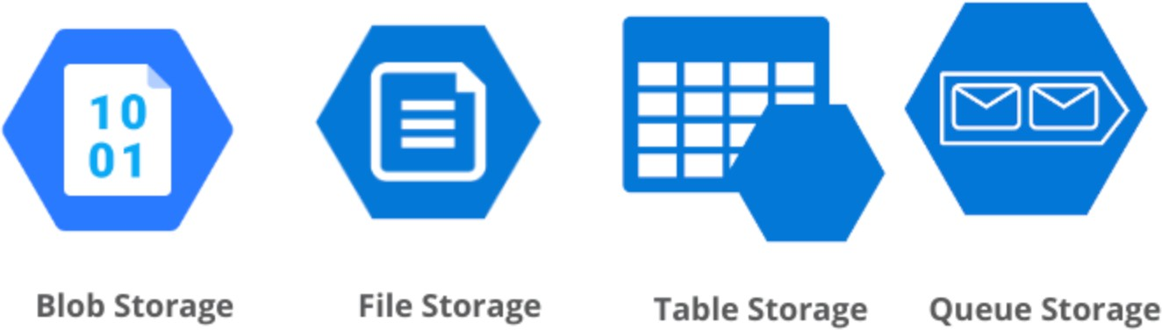There are 4 Types of Storages

1. File Storage
2. Blob Storage
3. Table Storage
4. Queue Storage

# File Storage

Azure File Storage is optimal for sharing files across users and applications that need classic file system access.

# Use it when:

* + You need to replace or supplement on-premises file servers (e.g.Windows File Server).
  + Multiple VMs or applications need access to the same shared files.
  + Lift-and-shift of legacy apps that expect a traditional file system.
  + Mounting file shares on VMs or containers (Windows/Linux).

# Example Scenarios:

* + - Hosting shared configuration files for distributed applications.
    - Storing user profiles in a Virtual Desktop Infrastructure (VDI).
    - Backup storage that needs to be accessed from different VMs.

# Blob Storage

Azure Blob Storage specializes in scalable, cost-efficient storage of unstructured data such as binary files, images, audio, video, or documents.

# Use it when:

* + You need scalable storage for images, videos, documents, or big data.
  + You're building apps that stream media or deliver content (CDN).
  + You want to archive infrequently accessed data (Cold or Archive tier).
  + You need to store backups, logs, or telemetry data.

# Example Scenarios:

* + Hosting website images, CSS, and JavaScript files.
  + Storing user-uploaded files in a web application.
  + Video/audio streaming applications.
  + Data lake storage for analytics (especially with Azure Data Lake Storage Gen2).

# Table Storage

Azure Table Storage is a NoSQL key-value store ideal for large amounts of structured, non-relational data that needs fast, flexible access.

# Use it when:

* + You need fast and cost-effective access to structured data without complex joins.
  + You want to store large volumes of semi-structured data.
  + 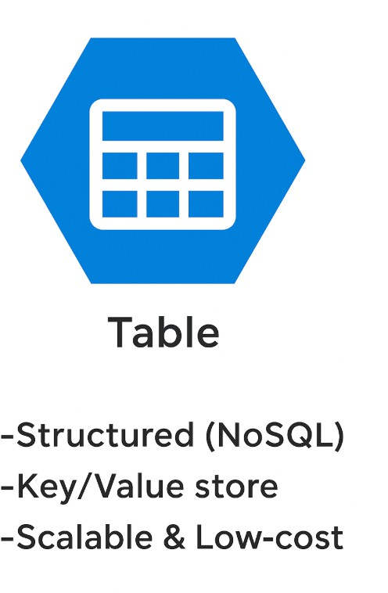Your application needs flexible schema (e.g., each row can have different columns).

# Example Scenarios:

* + - Storing user profile or device metadata.
    - Application logs or diagnostics data.
    - Lightweight inventory, order tracking, or IoT data.

# Queue Storage

Azure Queue Storage provides reliable messaging between distributed applications and components, focused on asynchronous communication.

# Use it when:

* + You need to enable asynchronous communication between application parts.
  + You want to build reliable, loosely coupled architectures (e.g., microservices).
  + You want to buffer and process workloads.

# Example Scenarios:

* + Processing user requests (e.g., image processing, order processing) in the background.
  + Decoupling a web front end from a back-end worker role.
  + Implementing retry logic or task queues in cloud apps.